Anglia Region Pensioners’ Association NPC
(National Pensioners’ Convention - www.npcuk.org)
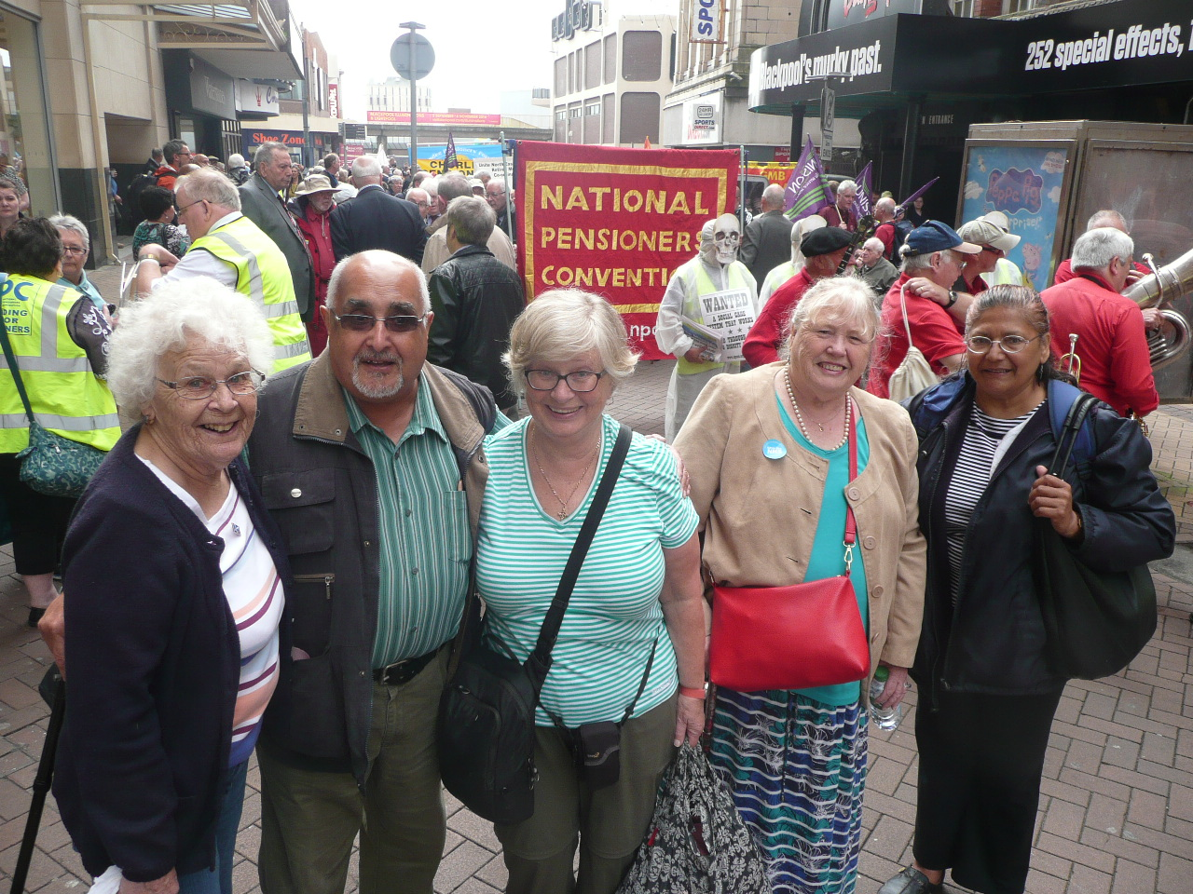
East Anglia Region – www.anglianpc.com

“Us today, you tomorrow,
we’re all in this together!”

We are a campaigning group of seniors, organised in affiliated local groups or as individual members, promoting the welfare and interests of present and future pensioners living in Norfolk, Suffolk, Essex and Cambs. Through our membership of the National Pensioners’ Convention, we assist and promote campaigns on the national stage.

Our aims include campaigning for:
> a decent state pension above the official poverty line
> dignity, financial security and respect in retirement for older people.
> a free national health and care service paid out of national taxation.
> retention and development of the national free bus pass scheme.

We are not party-political:
We fight for an end to lip-service to pensioners, and to win real change to reward years of service to our country. The future for the pensioners of today and tomorrow lies in our hands: so don’t just complain - campaign! Help us take our message out to the wider public. We need your active support. If you are 55 + please come and join us – it’s your future as well as our present situation at stake! Local group membership costs a pound or two per year. Direct regional individual membership £5 per annum. Group affiliations welcome at £20 per annum.

Our tri-annual general and planning regional meetings around East Anglia are lively, informative and sociable and local branch groups in Norfolk and Suffolk also hold regular meetings with something for everyone. It is never too late to make new friends and have your say as your ideas and opinions are welcome.

Our yearly calendar of events includes campaign updates and attendance at assemblies and rallies that fight for and support causes of importance to pensioners. Donations for these are welcome to assist in conducting effective campaigns. We hold occasional leaflet stalls in East Anglia so as to liaise with the general public and attend a National Annual Pensioners’ Convention to liaise with regional and national colleagues and guest speakers.
HOW TO JOIN
Contact the Treasurer Mr Sam Sirdar – use this form >>>>
Tel: (01603) 413581 email: samsirdar@googlemail.com

INDIVIDUAL ASSOCIATE MEMBER: £5.00 per annum

Please print
Name......................................................................................Date..................
Address............................................................................................................
..........................................................................................................................
Postcode....................................Tel..................................................................
Email................................................................................................................

I consent to NPC EAST ANGLIA REGION holding my personal contact details & understand I have the right to obtain the ANGLIA REGION NPC data protection privacy statement.
Signed................................................................................................................

Enclosed £5.00. Donations always appreciated.

Cheque payable to - ANGLIA REGION PENSIONERS’ ASSOCIATION.
Send to: Mr S. Sirdar, 9 Cromwell Road, Sprowston, Norfolk, NR7 8XH.
======================================================

GROUP MEMBERSHIP AFFILIATION: £20.00 per annum

Please print- Name of Secretary....................................................................
Group/Organisation.......................................................................................
Address............................................................................................................
..........................................................................................................................

Postcode...........................................Tel...........................................................
Email ...............................................................................................................

I consent to NPC EAST ANGLIA REGION holding my personal contact details & understand I have the right to obtain the ANGLIA REGION NPC data protection privacy statement.
Signed........................................................................................................................................................

Enclosed £20.00. Donations always appreciated.

Cheque payable to - ANGLIA REGION PENSIONERS’ ASSOCIATION.
Send to: Mr S. Sirdar - address above.

