
Head Office: Marchmont Community Centre, 62 Marchmont Street, London WC1N 1AB
Tel: 020 7837 6622  Email: info@npcuk.org  Web: www.npcuk.org

15 February 2021

The Editor
Daily Mail Letters

Emailed to: letters@dailymail.co.uk

Dear Editor,

Re: Right of reply to ‘Value for Money’ letter on increase to TV licence fee

On behalf of the National Pensioners’ Convention (NPC), I would like to respond to a Letter to the Editor under the heading ‘Value for Money,’ printed in your issue on Thursday 11 February. We wish to exercise our right of reply to the letter (which specifically names the NPC and myself as General Secretary) with factual information that challenges the judgemental attitude of the writer.

The NPC represents around 1.5 million pensioners across the UK in affiliated groups. Our main objective is to promote the welfare and interests of all pensioners, as a way of securing dignity, respect and financial security in retirement. We do this not just for the pensioners of today but for those who will retire in the future. Safeguarding what we have now will mean that those who follow us will not be treated less favourably.

Our campaign for the free TV licence for all over 75’s challenges the government’s decision to off-load the responsibility to the BBC. The BBC are a broadcasting company not an arm of the DWP and the country’s welfare services.

The writer of the ‘Value for Money’ letter seems to believe an extra £1.50 a year for a TV licence would be hardly ‘noticeable’ to most people. The NPC would firstly like your readers to understand that there are hundreds of thousands of older people whose incomes are already stretched to the limit. Their incomes are just £1 or £2 above the pension credit level that would allow them to access a free TV licence if they are over 75. (Currently the weekly cost of paying for a TV licence is around £3 – a lot of money for many).

Secondly, the increase in the licence fee is set by the government, not by the BBC.
We would like people to understand this licence fee rise is not the only increase older people will be met with this year. There will be increases in rent, council tax, utility bills and food – all needing to be found from a fixed income just above pension credit level.

Thirdly, poverty is increasing in the pensioner population, i.e.18 per cent of those aged 80-84 and 21 per cent of those aged over 85, compared to 15 per cent of 65-69 year olds. Poverty affects 14 per cent of women compared to 17 per cent of men with 22 per cent of single women pensioners, compared to 19 per cent of single men and 13 per cent of couples. In total the number of older people impacted by poverty has risen to 1.9 million.

Every day, older people are making critical decisions about how to spend their money. Do they eat, heat their homes in this cold weather, or pay for a TV licence? Now they will have a very stark choice as inflated bills fall through the letter box.

Loneliness and isolation have a massive impact on the physical, emotional and mental well-being of older people. The TV is often the only companion and source of information older people have. That is why the NPC will continue to argue for free TV licences to be reinstated to all over 75’s fully funded by the government as part of a wider package of entitlements that serve to supplement the least adequate state pension in the economically developed world.

Yours sincerely,
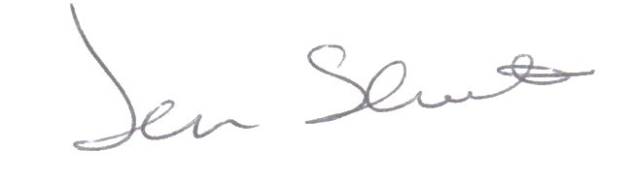
Jan Shortt
General Secretary

*Inclusion:

Copy of ‘Value for Money’ letter in the Daily Mail, Thursday, 11th February, 2021.



